OO Programming Fundamentals

Practical Week 3 – 29th September 2014

Create a Practical Week 2 folder in your Java folder on your G drive

G:\Java\Practical Week 3

- Save all the following exercises into the Practical 3 folder

Exercise 1
Enter program from notes asking user to enter 4 different data types and inputting values from the keyboard, then print each to the screen.

Create project in Practical Week 3 folder as: ex3a
Sample Output
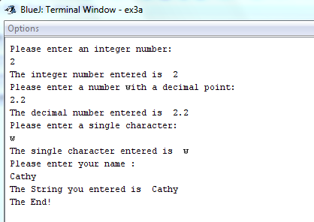

Exercise 2
Write a program which asks the user to enter the length and width of a room in metres calculates and displays the size of carpet needed in square metres.

Create project in Practical Week 3 folder as: ex3b
Sample Output
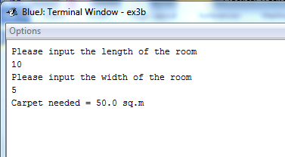

Exercise 3:
Assuming the carpet for the room in Exercise ex3c costs €5 per square metre, amend the program to calculate and display the cost of the required amount of carpet.

Create project in Practical Week 3 folder as: ex3c
Sample Output

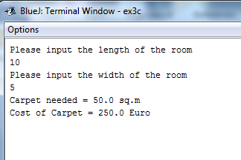

Exercise 4:
Design and build a program to input the year in which a user was born and display the age they will be in the year 2050.

Create project in Practical Week 3 folder as: ex3d
Sample Output


Exercise 5:

Design and build a program to input a set of 4 numbers and display their average (be careful with data types)

Create project in Practical Week 3 folder as: ex3e
Sample Output
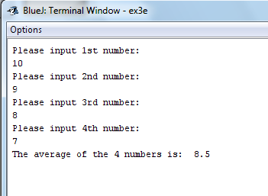

Exercise 6:
Design and build a program to input the number of €5, €10 and €20 notes a user has, then display the total number of notes and the total amount of money.

Create project in Practical Week 3 folder as: ex3f
Sample Output
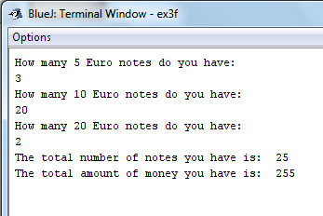

Completing this weeks’ Practical:
- When you submit work, you will send it in zip file format.
- To create a zip file of your practical work:
  - In Windows Explorer, right click on the Practical Week 3 folder that contains your work.
  - When the context menu appears, choose the Send to option, followed by the Compressed (zipped) folder.
  - This will create a new file called Practical Week 3.zip in your current folder
- Note: If you are using your own laptop, you can choose to install very good (and free) compression software called 7zip. Just search for it in Google and download it.

*** It is this zipped file that you will upload into Moodle.***

